This document is to introduce the **"New" Heidenhain LS187** linear scales which are to replace the "Older" Heidenhain LS703 and Heidenhain LS704 Linear scales.

The Heidenhain LS703 and LS704 scales were most commonly used as CNC Feedback scales for the K&T Orion Series Machining Centers, other OEM's are Giddings & Lewis Machine, Monarch Machine and Cincinnati Millicron.

With today's technology speeding along manufacturers of electronic equipment are faced with the fact that some of the IC chips and Semi-Conductors that they are using with the older products are just no longer available! and if they are still available these components are becoming very expensive to make because they require a separate assembly line and ultimately make them soon to be obsolete products. This is the reason why you the consumer must realize that there is a day coming where your Linear scale or Rotary encoder may no longer be supported and you must replace it with the newest style or version.

Here is an example of the Heidenhain LS703 and LS704 series scale 40"/1040mm. The LS703 was replaced with the LS704 22-years ago. To repair a LS703 or LS704 the scanning unit alone is $1,400.00 dollars, now add lip seals at $100.00 and labor to rebuild the scale and you are in the $1,700.00 dollar neighborhood. Problem is this; it is that you still have is an old scale with the old scanning unit technology and will still need to replace the scale someday in the future.

Let's look at a New Heidenhain LS187-1040mm scale. Cost of the scale is $2,046.00 adapter cable $125.00 and a signal adapter at $165.00 for a total of $2,336.00. For just an additional $636.00 you can have the most up-to-date linear scale technology in your machine.1, 2

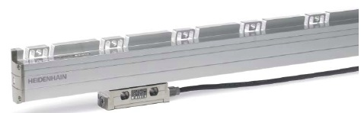 Why not take advantage of the "New LS187 scale ?

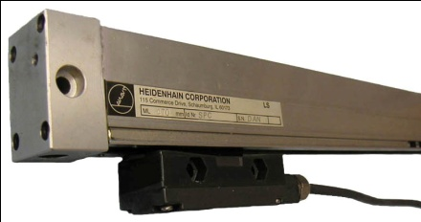

Download Line drawing of "Old" LS703/704 Download Line drawing of "New" LS187

Download List of LS703 scales Download list of LS187 scales

Download List of LS704 scales

1. Prices will vary from different scale lengths. Shorter scales are cheaper in price.

2. New LS187 scales require new mounting, they have more mounting holes and the scanning head my require a new bracketry.