Sealed Linear Encoders

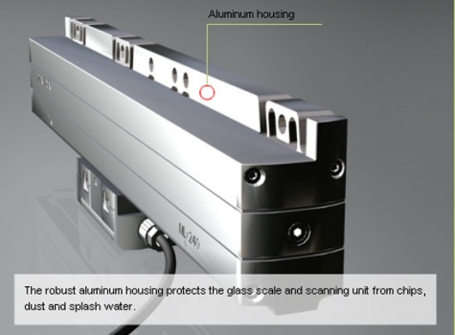

Sealed linear encoders from HEIDENHAIN are protected from dust, chips and splash fluids and are ideal for operation on machine tools. An aluminum housing and elastic sealing lips protect the scale, scanning carriage and guideway from chips, swarf, dirt and splashwater The scanning carriage travels in a low-friction guide within the scale unit. It is connected to the external mounting block by a coupling that compensates unavoidable misalignment between the scale and the machine guideways.
Sealed linear encoders are available with full-size scale housings for high resistance to vibration up to 30 m measuring length, as well as slimline scale housing for limited installation space up to 2040 mm measuring length.
Review Sealed Linear Encoder Catalog

