

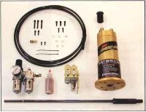

**MAXI TORQUE-RITE**

**A Power Drawbar that was designed from start to finish to be a Power Drawbar for all milling machines!**

**Maxi Torque-Rite's slim line design and powerful air cylinder can deliver up to 40-50 ft. lbs. of torque on the tool holder.**

***An increase of 50% more torque than our leading competitor!***

**Maxi Torque-Rite has less moving parts and O-rings to deliver years of trouble free service.**

**Made to fit any milling machine using an R-8 Collet.**

**Reg. Price $575.00 Web-Site Special $517.50**

**Call: Dan 414-315-3436**